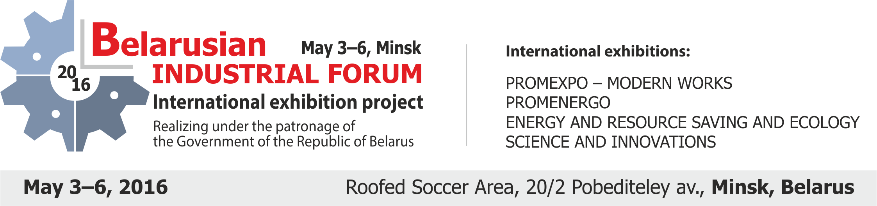
APPLICATION FORM №3 ORDER OF ADDITIONAL SERVICES Registration № _____
EXHIBITOR: | STAND NO.: ________

№ | Service denomination | Price, € | Quantity | Cost, €
1. | Design and decoration of stands
1.1 | Logo making and drawing for frieze panel / wall panel and other surfaces covering | 18 / 28
1.2 | Panel covering with 1-colored film, 1 sq. m. | 11
1.3 | Covering and removal of Customer’s film, 1 sq. m. | 5
1.4 | Full colored picture film drawing and surfaces covering, 1 sq. m. | from 25
1.5 | Dynamic and lighting advertising construction rent | from 77
1.6 | Advertising panels and plan-tables making | from 65
1.7 | Lighting stand design using neon, duralumin cord etc. (1 running m.) | from 20
1.8 | Lifting and lowering of advertisement on metallic construction with application point load till 20 kg | on request
1.9 | Lifting and lowering of advertisement on metallic construction with application point load from 21 till 40 kg | on request
1.10 | Lifting and lowering of advertisement on metallic construction with application point load from 41 till 60 kg | on request
1.11 | Lifting and lowering of advertisement on metallic construction with application point load over 60 kg | on request
2. | Invitation on exhibition exposition, 50 items | 8
3. | Permanent exhibition pass, 1 item | 1,3
4. | Invitation on business reception, 1 item | 50
4. | Advertisement services
4.1 | Advertisement on radio center, 1 min. | 2
4.2 | Disposal of advertisement shields, rolls, and other advertisement constructions inside hall and near the exhibition hall entry, 1 sq. m. / Advertising onto floor of the exhibition hall | 70
4.3 | Disposal of advertisement (flag / banner) above exhibition stand,  1 sq. m. (+ lifting and lowering) | 30 / +
4.4 | Lifting and lowering of advertisement (flags, banners) inside pavilion: via using of upper metallic arches of cupola for hanging / via using of bridge for hanging, 1 anchorage point | on request
4.5 | Disposal of flag of Exhibitor at flagstaff forward of the pavilion, 1 item | 60
4.6 | Promoter service, 1 person per 1 day | 50
4.7 | Disposal of advertising materials into the informational packages for Exhibitors, all packages | 90
5. | Advertisement on invitation tickets (circulation not less 12 000 pcs.)
6.1 | Disposal of logo on invitation tickets | 85
6.2 | 4th page of invitation ticket (216 x 102 mm, 3 mm for trim) | 250
6. | Publicity in the exhibition e-catalogue
6.1 | Disposal of additional logo, 1 item | 15
6.2 | Insert of enterprise information in catalogue with logo (+post expenses) | 50 (+40)
6.3 | Disposal of presentation of Company (up to 50 Mb) | 50
7. | Placing information on WEB-site of EXPOFORUM EC for 1 year
7.1 | Address, logo, textual information with link and banner (to 30 Kb) | 127
7.2 | Page development from the participant material (to 150 Kb) | 170
7.3 | Prior highlighting of Your Company within the list of Participants | 20
8. | Organization of seminars, presentations and press conferences
8.1 | Hall rent, 1 hour (microphone, speakers, screen) | 100
8.2 | Multimedia projector rent, 1 hour / during the exhibition | 34/135
8.3 | Gas panel rent, during the exhibition only | 180
8.4 | Notebook rent, 1 hour / during the exhibition | 34/135
8.5 | Magnetic flipchart board rent with fastening for paper block, 1 hour | 20
9. | Internet access
9.1 | Wi-Fi Internet access (up to 5 devices, not less 1 Mbit/sec) | 45
9.2 | Wired Internet access, leased line | 120
TOTAL (without VAT*) :
>>> To see photos of exhibition equipment and services You can reach www.exposervice.by<<<
* In case of mounting of electric equipment outside the pavilion, cost improves on 100%
** In case of mounting of equipment on the height more than 2,5 m., cost improves on 50%
*** In case of order of additional space, equipment, and/or services in period from 2nd TILL 6th OF MAY 2016, cost improves on 50% or will not accept. *VAT = 20%

